- Open OnlineRetail.csv in Excel and use the Filter feature to display only the transactions made by customers from 'United Kingdom'. Count how many unique CustomerIDs made purchases from the UK.
ANSWERS:
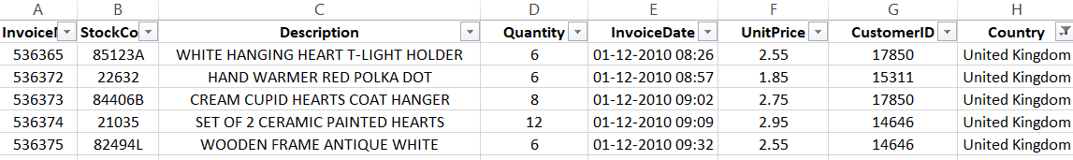
- Create a PivotTable in Excel to analyze total sales (Quantity * UnitPrice) by Country. Identify the top 3 countries by total sales and write their names in a cell below your table.
ANSWERS:
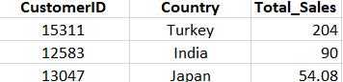

- Using Excel formulas, calculate the average order value (total sales per InvoiceNo) for all customers. Highlight any InvoiceNo where the order value is above ₹10,000.

Hint: Create a new column for order value, then use Conditional Formatting to highlight.
ANSWERS:
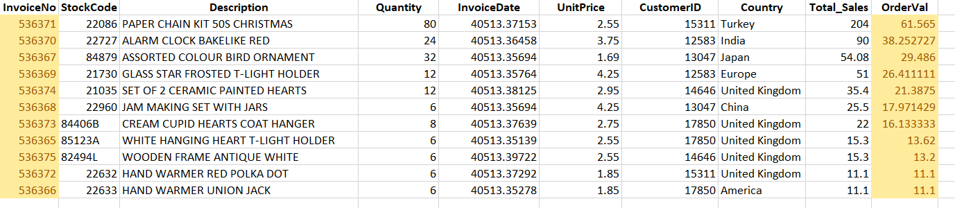
- Perform a t-test in Excel to compare the average order value between customers from 'France' and 'Germany'. State whether the difference is statistically significant at the 0.05 level.
Hint: Use the Data Analysis Toolpak's t-Test: Two-Sample Assuming Unequal Variances.
ANSWERS:
Ho: Sample mean is not significantly difference from population mean
H1: Sample mean is significantly difference from population mean

Significance Level: 0.05

Table:
P-Value | Column1 | Alpha
0.177 | > | 0.05
t-critic |  | t-stat
2.109 | > | 1.408

Decision: Fail to Reject null hypothesis
Conclusion: Here our p-value is greater than significance level (0.177 > 0.05) so we fail to reject null hypothesis. And we conclude there is not statistically difference from the customer order France to Germany.

- Use ChatGPT or Copilot to generate a summary of key customer purchasing patterns you observe from your analysis (e.g., high-value countries, average order size, seasonal trends). Copy-paste your summary into a new sheet named 'Insights'.
ANSWERS:
